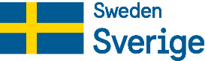
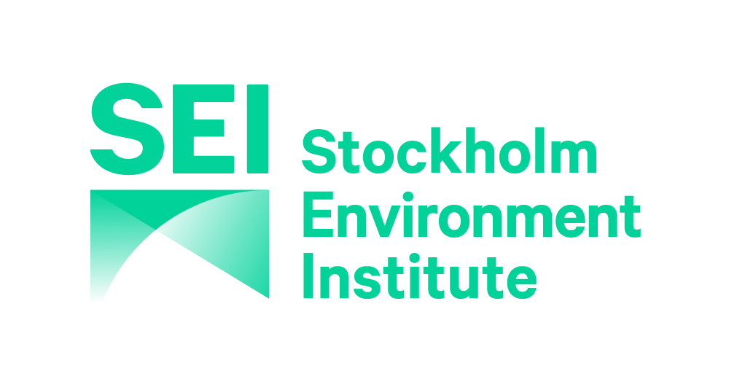

Concept Note: 2020 Regional Environmental Event
Strategic Collaborative Fund Phase 2 (SCF2), SEI

{Title}

Theme:

Tentative location(s)

Tentative event timeframe – Month/Year

Proponent Organization
Contact Person: Name and position
Address
Email
Tel.

{Date of Submission}

Rationale and relevance
(Maximum 400 words)
- Describe the research and policy context in the Asia region in particular to Southeast Asia and South Asia for the organization of the proposed event.
- Describe how the proposed event contributes to the theme/sub-theme(s) and how it addresses the issues described in the thematic call through research-to-policy dialogue.

Event design

Objectives
(Maximum 200 words, preferably in bullet points if including multiple objectives)
- Briefly describe the overall objectives of the proposed event(s). (one event or a series of link events)

Target participants
(Maximum 150 words, preferably in bullet points or table if including multiple target participants)
- Specify the target participants for the proposed event and if the event will include vulnerable and marginalized groups such as the poor, youth, non-normative genders and sexualities (NNGS), women and ethnic people. We strongly encourage the participation of a diversity of people and groups.

Geographical scope
(Maximum 100 words)
- Briefly describe the event’s tentative geographical scope in Asia including Southeast Asia and South Asia. Please list the participating sub-regions, countries (at least 2 countries), transboundary areas and communities.

- Expected outcomes
(Maximum 300 words, preferably in bullet points, a result chain – how input and activities lead to results - can be added)
- Specify the outcomes you expect to achieve related to policy and practice as a result of the proposed event, which policy processes they will feed into, and at which level (e.g. sub-national, national, regional) they will occur. Outcomes are defined as medium and long-term changes in behaviour, relationships, activities or actions of target stakeholders (i.e. event participants).

Integration of gender and social equality, right-based approach and poverty reduction
(Maximum 300 words)
- Describe how gender equality is integrated in the design of the proposed event (i.e content, resource persons, event organization and participants).
- Describe how a right-based approach is integrated in the design of the proposed event.
- Describe how poverty reduction is integrated in the design of the proposed event.

Communication and Monitoring and Evaluation Plan
(Maximum 300 words)
- Outline the key communication products you plan to develop for the event promotion and knowledge dissemination.
- Describe how the organizers will monitor and document the impacts of the proposed event in terms of practice and policy changes.

Draft agenda
(Maximum one page, preferably in table)
- Briefly describe the duration and main activities of the proposed event. E.g. will there be field visit?
- Describe any innovative approaches, methods and tools to ensure stakeholder interaction and equal contributions of participants.

Organizational capacity
(Maximum 200 words, multi-country partnership is encouraged)
- Describe the capacity of the lead organization and at least 2 potential consortium partners in organizing the regional event.

Lead Organization – Lead organization name, country, type
Contact Person:
Phone:
Email:
Partner 1 – Partner 1 name, country, type
Contact Person:
Phone:
Email:
Partner 2 – Partner 2 name, country, type
Contact Person:
Phone:
Email:

Budget Estimate

Please provide the budget estimate for the proposed event in the suggested table below or modify as appropriate:

No | Expenditure category | Expenditure (SEK) |  |  | Income (SEK) |  | Remarks
 |  | Unit cost | Quantity | Amount | Expected grant support | Expected  co-funding
1 | Personnel
2 | Workshop
3 | Travel
4 | Accommodation
5 | Materials and supplies
6 | Miscellaneous
7 | Administrative/overhead (not exceeding 15%)
Total (SEK)

Note: - Please indicate co-funding amount to the event (if any).
- Please use Swedish Krona (SEK) as currency

Please refer to call text to identify the appropriate theme and sub-theme(s) for the proposed event.

