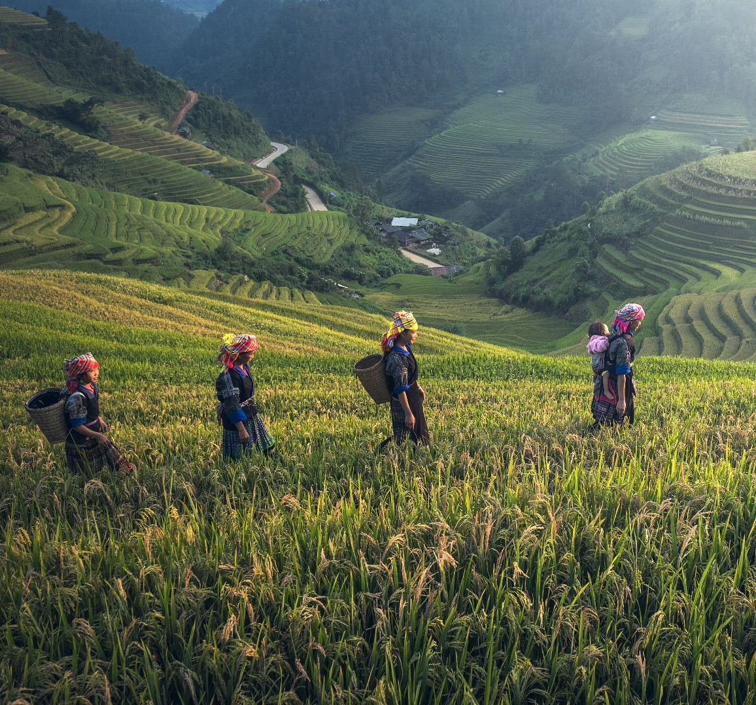
Concept Note: 2023 Regional Environmental Policy Dialogues
Strategic Collaborative Fund Programme Phase 2 (SCF2)
SEI Asia

Title: Click here to enter text.
Theme: Click here to enter text. (Please refer to the call text to identify the appropriate theme and sub-theme(s) for the proposed event(s). Delete the instruction texts in this template before submitting.)

Proposed location(s): Click here to enter text.
Proposed event timeframe – Month/Year

Photo: Walpaperflare

Proponent Organization: Click here to enter text.
Contact Person: (Name and Position)
Address: Click here to enter text.
Email: Click here to enter text.
Tel.: Click here to enter text.
{Date of submission}

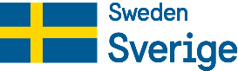

Rationale and Relevance
- In up to 400 words, describe the context (problems, issues, challenges) related the Thematic Call in the Asia region for the organization of the proposed event.
- Describe how the proposed event(s) contributes to the theme/sub-theme(s) and how it addresses the issues described in the thematic call, including the intersectional gender and human rights issues, through research-to-policy dialogue and other policy influencing activities.
- Please refer to the guidance note on mainstreaming gender and human rights-based approaches to better elaborate these aspects into your problem statement.
[Add your text here]

Event Design
- In up to 200 words, please provide a summary of your proposed event(s). You may also indicate if the event will be held in-person, online, or hybrid.
[Add your text here]

Event Details and Objectives
- In up to 200 words, briefly describe the overall objectives of the proposed event(s), preferably in bullet points if including multiple objectives. Your proposal can be one event or a series of interlinked events.
- If you propose a series of events, please fill the following table with each event-specific objective(s), format and delivery methods in the event description.
- If you propose a single event, you may modify the table to put your proposed event agenda.
[Add your text here]
Event Name | Brief Description | Objective(s) | Timeline
[Insert event #1 here] | [Add description here] | [Add objective(s) here] | [Add rough timeline here]
[Insert event #2 here] | [Add description here] | [Add objective(s) here] | [Add rough timeline here]
[Insert event #3 here] | [Add description here] | [Add objective(s) here] | [Add rough timeline here]

Integration of the Intersectional Human Rights-Based Approaches
- In up to 300 words, please describe how you will integrate (i) gender equality and intersectionality; (ii) rights-based approaches; and (iii) poverty reduction in the design and objectives of the proposed event (e.g., content, presenters, target audience, resource persons, event organization and participants, expected outcomes, etc.).
- In the process, SEI Asia will provide support to strengthen applicants' skills and knowledge in human rights-based approach and intersectionality.
- To help you integrate these aspects, SEI Asia and RWI provide a guidance note for the potential grantees to refer to when designing the event.
[Add your text here]

Target Participants
- In up to 150 words, specify the target participants for the proposed event and how the event will include the disadvantaged and persons living in situations of vulnerability such as the poor, youth, non-normative genders, and sexualities (NNGS), women, ethnic minorities, person with disabilities, migrants, and Indigenous peoples.
- The participation of a diversity of people and groups is mandatory both as presenters and in the audience.
- Preferably in bullet points or a table if including multiple target participants.
[Add your text here]

Geographical Scope
- In up to 100 words, briefly describe the event’s tentative geographical scope in Southeast and/or South Asia and provide the appropriate justifications. Please list the participating sub-regions, countries (at least 3 countries), transboundary areas and communities.
- If you plan to cover specific countries in your event(s), we require a participation of at least three countries from Asia.
[Add your text here]

Risks Mitigation
- Please elaborate the potential risks that your proposed event(s) may have, e.g., Covid-19 related disruptions, political instability, safety and security, and how you plan to mitigate them.
- If holding an online or hybrid event is considered as a risk mitigation strategy, please elaborate how you can ensure a meaningful participation from diverse participants, including the marginalised and vulnerable groups, in such formats.
[Add your text here]

Expected Policy Outcomes and SDGs Contribution
- In up to 400 words, specify the outcomes you expect to achieve related to policy and practices as a result of the proposed event(s). You may also link with the policy framework identified in the thematic calls and expand it as appropriate.
- Which policy processes will they feed into, and at which level (e.g., sub-national, national, regional) will they occur? For events targeting national and sub-national policy levels, please ensure that it covers at least three different countries as indicated in your geographical scope.
- Outcomes are defined as medium and long-term changes in behaviour, relationships, activities, or actions of the target stakeholders, i.e., event participants and policy makers.
- Please identify and explain which SDG targets the proposed event aims to contribute.

[Add your text here]

Monitoring, Evaluation, and Learning (MEL)

Theory of Change
- Based on the following table, develop a simplified Theory of Change for your proposed event(s) and the intended outcomes. Please align with the expected results specified in the Thematic Calls and integrate gender and human rights (see the guidance note).
Title:
Overarching Goal(s):
Activities | Outputs | Outcomes
Activity #1
Activity #2
Activity #3

Monitoring, Evaluation, and Learning Plans
- Please indicate the potential Monitoring, Evaluation, and Learning (MEL) tools that you would like to employ in your proposed event(s).
- SEI Asia requires the grantees to utilise multiple MEL tools, including the pre- and post-event surveys. In addition to these tools, you are free to add other appropriate MEL tools for your events, e.g., mentimeter, attendance, audio-visuals, etc. Please refer to our MEL Guidance Note to integrate the tools we use in SCF2 into your proposed activities.

Activities | MEL Tool(s) | Details
Activity #1
Activity #2
Activity #3

Communications and Policy Products
- Please fill the following table with your communications and policy products. The products that you plan to develop should cover the pre-event, event, and post-event stages.
- Each product should include the objectives, target audience, and distribution channels.
- The communication products should clearly show how it can influence policy and practice in your specific subject area.

Communications & Policy Product | Objectives | Target Audience | Distribution Channel(s) | Timeline
E.g., press release, video, infographic, blog, podcast, etc.
E.g., policy briefs, white papers, declarations, etc.

Organizational Capacity
- In up to 250 words, please elaborate your organisations or consortium’s capacity in conducting the proposed event(s). You may showcase your past engagements with the proposed stakeholders, similar events or projects, and existing or future plans on the subject area(s) that are relevant to your event(s).
- We strongly encourage a multi-country partnership comprising of at least three organisations from different countries/sub-regions in Southeast and/or South Asia to showcase regional collaboration.
- In addition, if at least one of your events will be held online or hybrid, please elaborate your past experience in handling such a setting.
[Add your text here]

Lead Organisation – Lead organization name, country, type
Contact Person: Click here to enter text.
Phone: Click here to enter text.
Email: Click here to enter text.
Partner 1 – Partner 1 name, country, type
Contact Person: Click here to enter text.
Phone: Click here to enter text.
Email: Click here to enter text.
Partner 2 – Partner 2 name, country, type
Contact Person: Click here to enter text.
Phone: Click here to enter text.
Email: Click here to enter text.

Budget Estimate
- Please provide the budget estimate in Swedish Krona (SEK) for the proposed event in the suggested table below or modify as appropriate.
- Please indicate co-funding amount to the event (if any).
No | Expenditure category | Expenditure (SEK) |  |  | Income (SEK) |  | Remarks
 |  | Unit cost | Qty. | Amount | Expected SCF2 grant support | Expected  Co-funding
1 | Personnel
2 | Sub-contract
3 | Workshop
4 | Travel
5 | Accommodation
6 | Materials and supplies
7 | Miscellaneous
8 | Administrative/overhead (not exceeding 15%)
Total (SEK)

The Strategic Collaborative Fund Phase 2
Stockholm Environment Institute
10th Floor, Kasem Uttayanin Building, 254,
Chulalongkorn University, Henri Dunant Rd,
Pathum Wan District, Bangkok, Thailand 10330

Administrative/overhead is not allowed in case the personnel rates already include these cost elements. If the proposal is selected, you will be required to provide the personnel cost breakdown and relevant policies.

